Open Education Resource: Flipping the classroom with MOODLE Work done as part of AICTE approved FDP on Use of ICT in Education for Online and Blended Learning
RC1150_Team6
R.Priyambiga
Rahesha Y Mulla
Shivaprasad S More

Table of Contents
Open Education Resource:
Section 1: Flipping the classroom with MOODLE............................................................................. 1
About the OER.......................................................................................................................................1 Learning Objectives ..............................................................................................................................1 Helpful Documentation for Tool Use....................................................................................................2

Section 2: Design Decisions..................................................................................................................3
Nature of Decisions taken .....................................................................................................................3

Section 3: OER Description...................................................................................................................4
Active OER ............................................................................................................................................4 Lesson Settings ......................................................................................................................................4
How to use this OER .............................................................................................................................8
Best Practices with Lesson Activity......................................................................................................10

Section 4: Evaluating Effectiveness of OER .......................................................................................11
Effectiveness at the student level.........................................................................................................11 Effectiveness at consumer level...........................................................................................................11

RC1150_Team6
R.Priyambiga
Rahesha Y Mulla
Shivaprasad S More

Open Education Resource: Flipping the classroom with MOODLE

About the OER
The open education resource is a collection of MOODLE Lesson activities that are useful as out-of-class activity while flipping the classroom. There are two lessons as part of this OER, one is storage classes and second is preprocessor and each deals with an aspect related to C programming.

- OER is downloadable from: https://github.com/priyambiga/Storage-classes-and-preprocessor-in-C/upload/master (prswordpress.Wordpress.com)
- Target Audience: Second year Engineering Students (CSE,IT)
- Tags: Flipped Classroom, MOODLE,Educational Technology, Engineering Students
- This resource is licensed under CC-BY-SA ver 4.0. You are free to use, distribute and modify it, including for commercial purposes, provided you acknowledge the source and share-alike.

Learning Objectives
After using this OER, learner will be able to:
  - Describe¹ Fundamental and object oriented concepts of Java.
  - Explain² Application of Interface, inheritance and packaging in Java.
  - Define¹ exceptions and file handling in java
  - Determine⁵ events in Java

Helpful Documentation for Tool Use
[1] for design and development of Lesson Activity in MOODLE (an Open Source Tool)

Section 2: Design Decisions
Nature of Decisions taken
The design decisions involved in the creation of this OER were of broadly three types:
1. Content Decisions
2. Pedagogic Decisions
3. Technology Decisions

1. Content Decisions

The content decisions related to:

- Decide specific Topic to be covered – Decided on CMaps –
What is Storage classes & preprocessor? Why Storage classes & preprocessor and How to use Storage classes & preprocessor? (Refered: http://quiz.geeksforgeeks.org/storage-classes-in-c)

2. Pedagogic Decisions
In a flipped classroom strategy, there are two Steps
– Out-of-class segment
This activity requires student to refer to some provided Video, Text etc. Basic levels of mcq questions to be asked along with the resources. It is available in youtube(https://youtu.be/NzQIHgT2_fg)
- In-Class segment.
This activity provide some problem statement and perform TPS activity.
Write your Think Phase Question here:  Output of following program?  #include <stdio.h>  int main()  {  static int i=5;  if(--i){  main();  printf("%d ",i);  }  } | Duration (in minutes)  3
What will Instructor do: Will provide the information about storage class: static,auto,extern,register& She asks students find the output of the program.
What will students do: Students will understand the concept and find out the output of the program

Write your Pair phase question here: Now discuss with your neighbors and find out which is the correct output. | Duration (in minutes)  6
What will Instructor do: She will pose the question and asks students to compare the results and she will roam around in the class to check whether active participation is happening in the class or not in pair phase.
What will students do: Students will identify the

Write your share phase task here:  Now share your answer with the class to check whether you have found out correct output. | Duration (in minutes)  6
What will Instructor do: She will conclude the answer by telling the usage of static storage classes after collecting the best answers from students.
What will students do: Students will discuss with each other and share their answer in the class.

Technology Decisions
While developing the Out-of-Class and In-class activities, the major technology decisions taken were:
a. Tool to be used for creating screencast –Screen-O-Matic(https://youtu.be/NzQIHgT2_fg)
b. MOODLE Lesson Activity for setting up Out-of-Class segment as it allowed guided self-learning.It is available in this link:()

Section 3: OER Description
- Settings Page of the Quiz

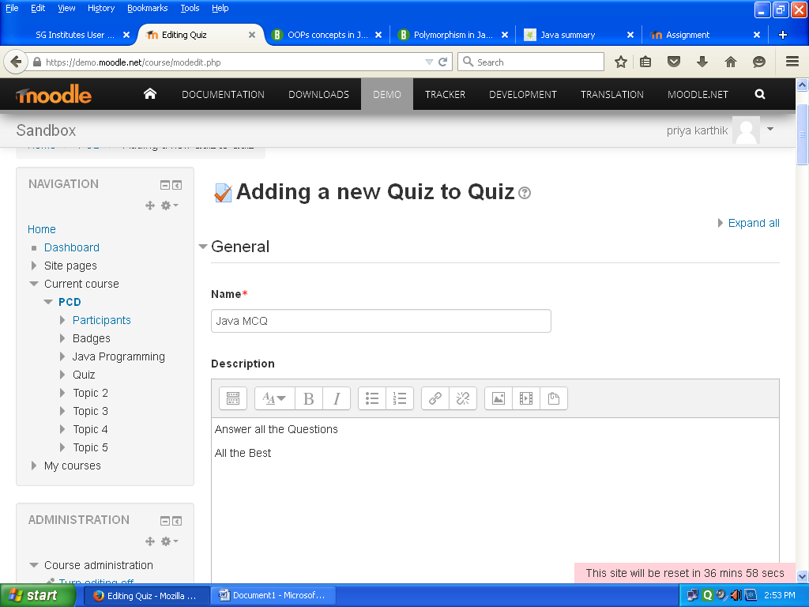

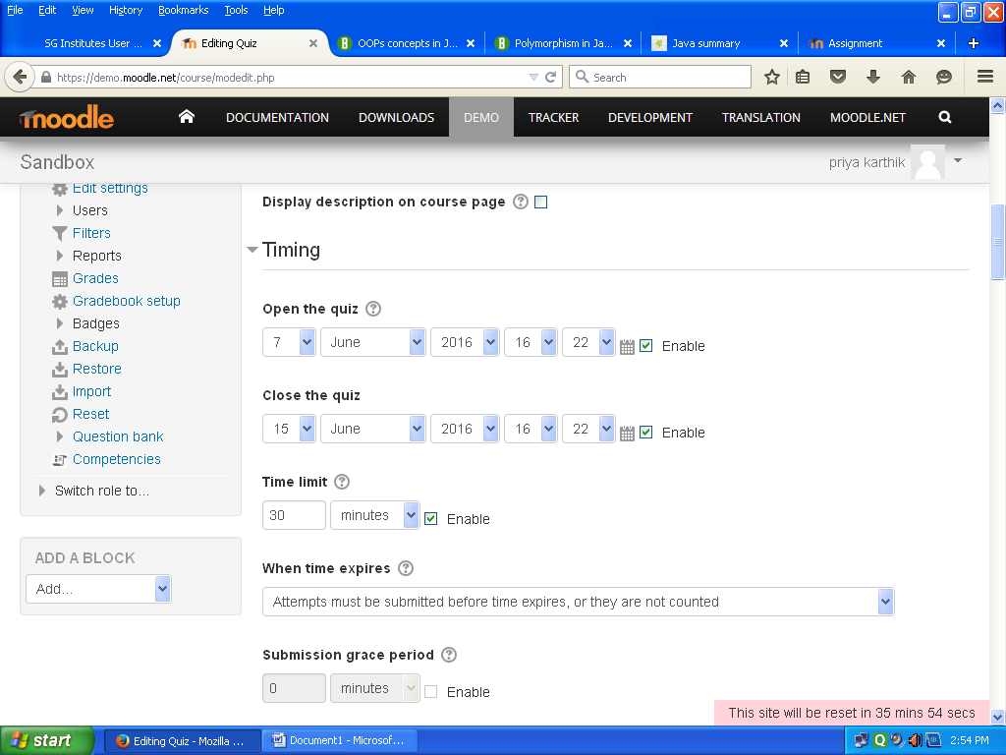
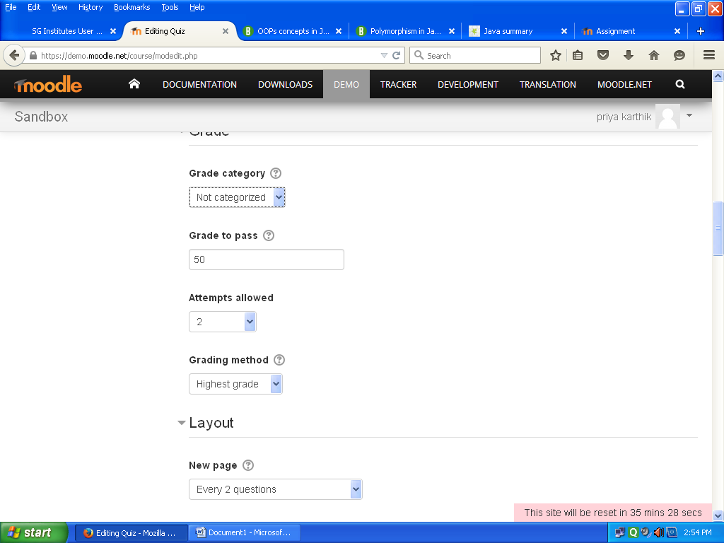
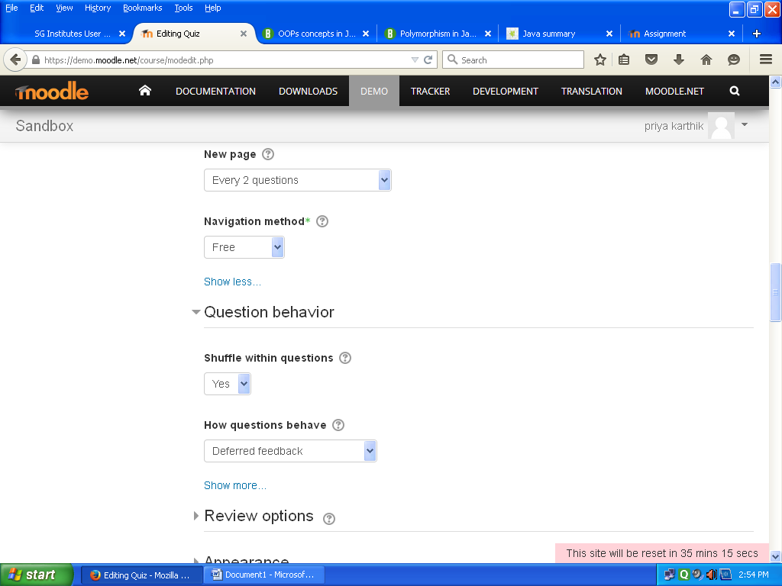
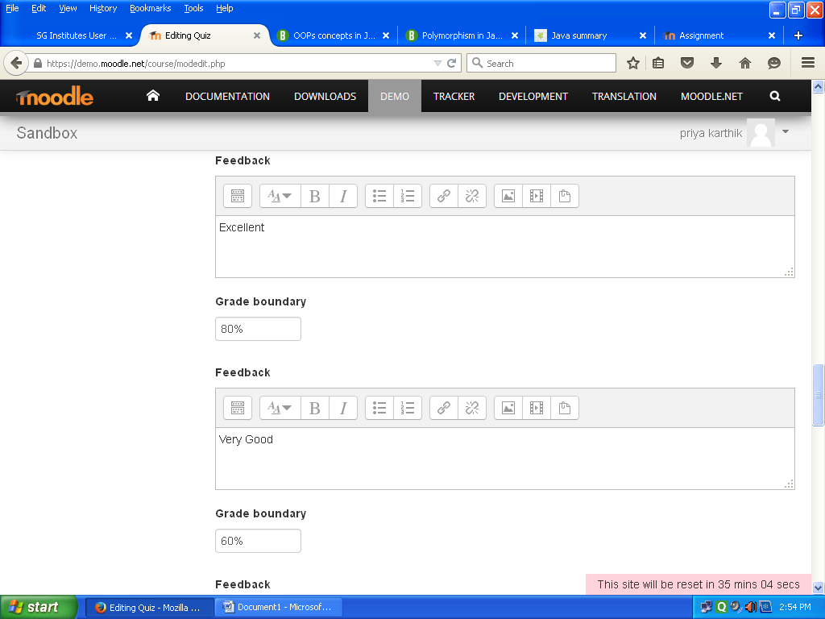
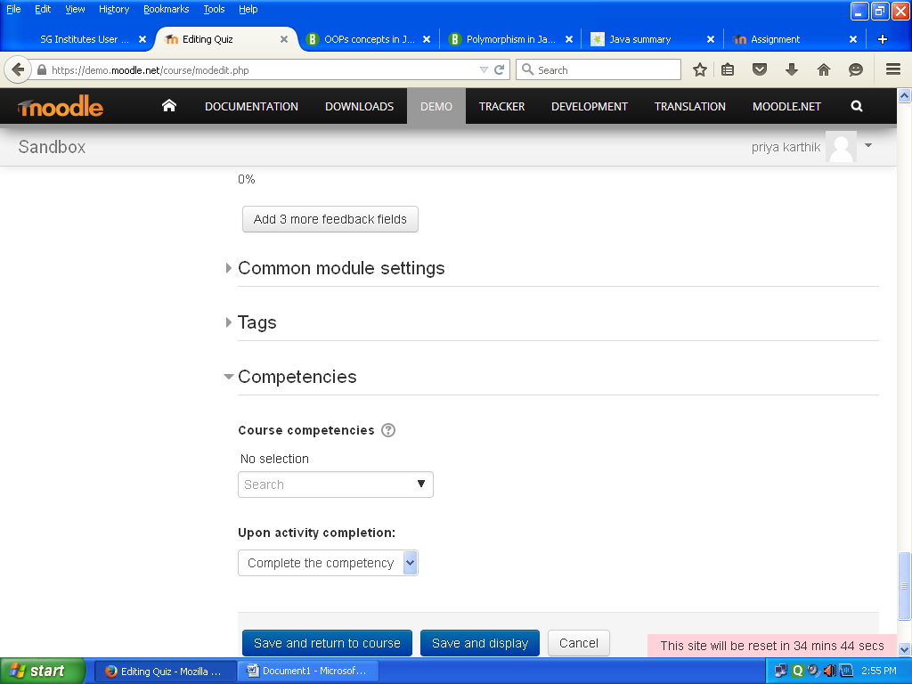

4. Editing Quiz
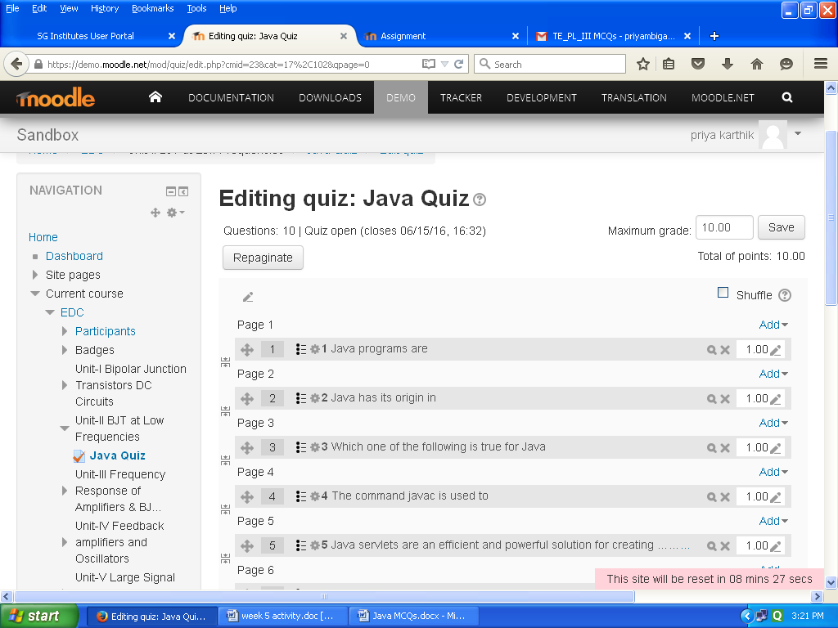
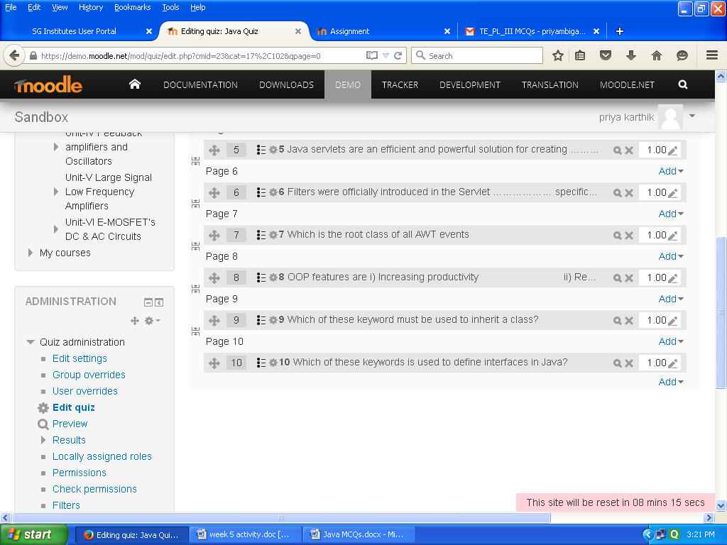

5. Actual Quiz
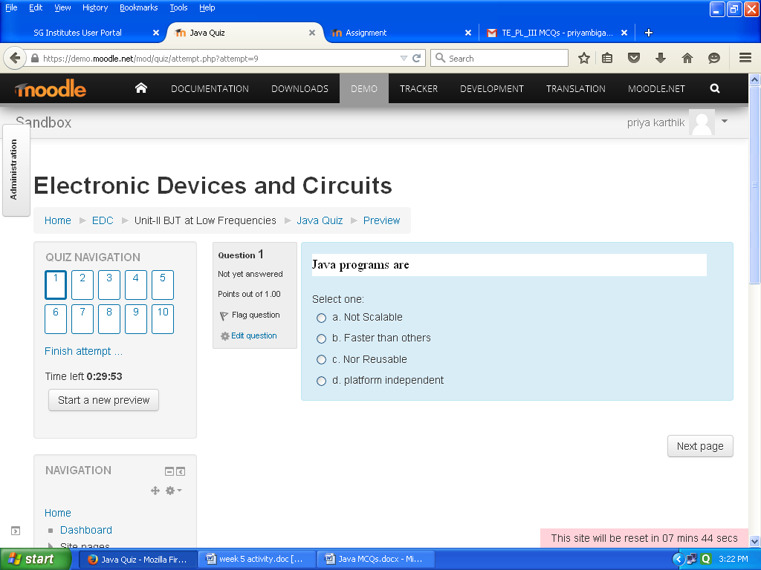
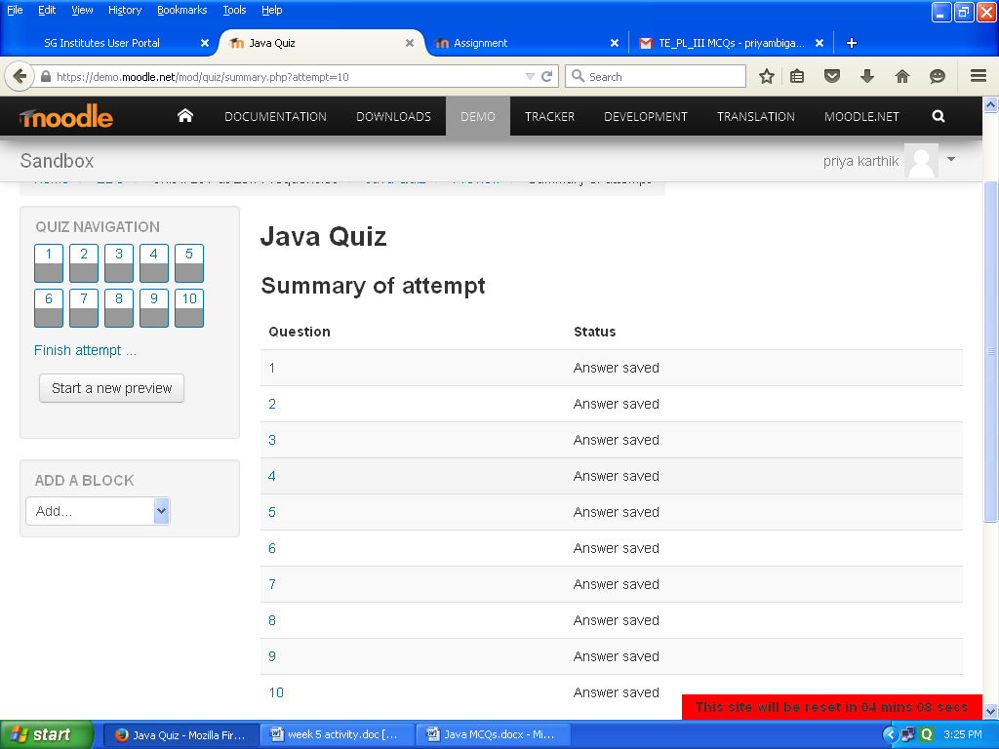
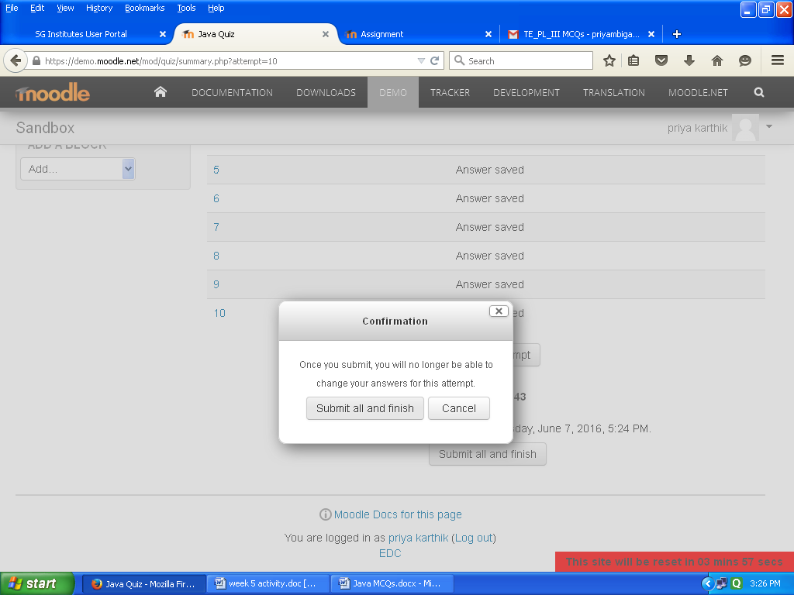
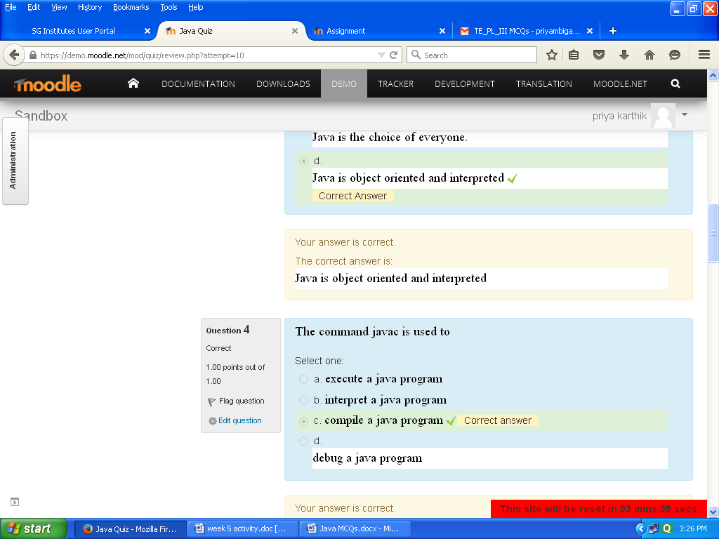
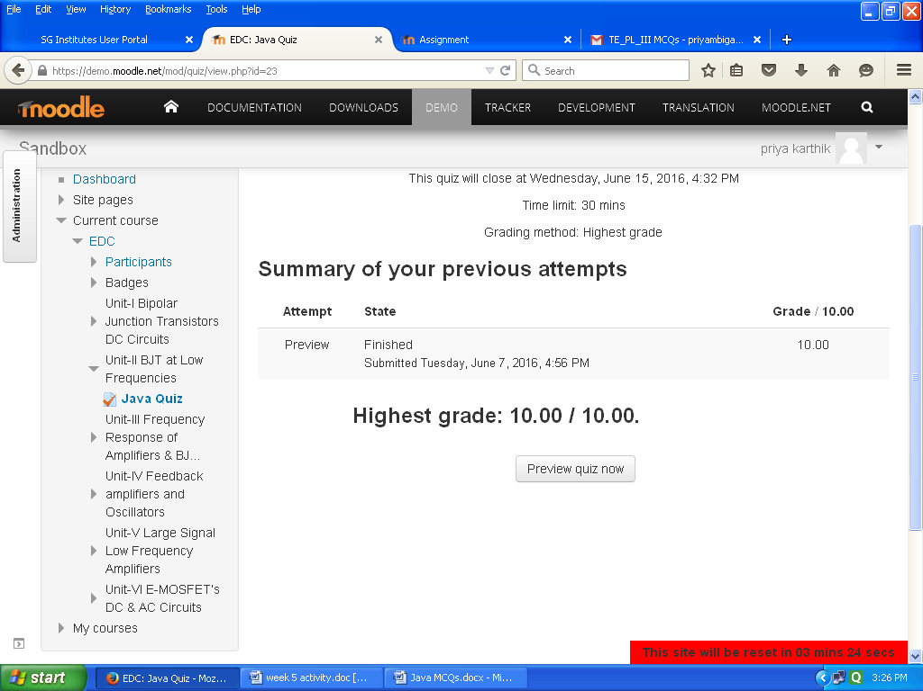

Section 4: Evaluating Effectiveness of OER

The OER effectiveness can be assessed at two levels:
1. At the student level
2. At the consumer level
Effectiveness at the student level
Effectiveness at the student level involves metrics related to student access of the resource and student learning. The Moodle lesson report can be used to evaluate this effectiveness, with the report showing the total number of students who accessed the reports (along with time) and their marks (based on their answers to MCQs). Additionally there is an option for teacher to grade essays and these marks also will be calculated if needed.
Effectiveness at consumer level
OER consumers are typically teachers who want their students to learn concept mapping. Linking a survey on three main constructs – Ease of Use, Concept Coverage and Concept Complexity, can help in identifying the effectiveness of this OER at consumer level. This has to be done as a follow-up activity.
Implementing Survey
Thus every user who downloads this resource will be asked their email address and as a follow up the survey will be send to their email address.
Survey Questions
Construct | Question | Scale
 | I found it easy to download
 | the Lesson Activity
 | I found the instructions to
 | setup the Lesson Activity
Ease of Use | useful in setting the activity | Strongly Disagree to
 | in my Course | Strongly Disagree to
 | in my Course | Strongly Agree (5-point
 | I was able to successfully | Strongly Agree (5-point
 | I was able to successfully | Likert Scale)
 | create Lesson in my own | Likert Scale)
 | course
 | The Lesson covers the
Concept Coverage | required concepts related to
 | concept maps that I need for

Section 5: Consolidated Log of Team Work

The consolidated log of team work is as shown below:
Activity | Team Member | Amount of Time | Additional Logs
 |  |  | if any
Discussion | R.Priyambiga | 20min | Discussed about storage classes and preprocessor
Discussion | Rahesh y mulla | 20min | Discussed about storage classes and preprocessor
Discussion | Shivaprasad S More | 20min | Discussed about storage classes and preprocessor
Tool Exploration | R.Priyambiga | 1 day | Video was created using Screen-o-matic to provide information about above said topic  Quiz was created using moodle
Tool Exploration | Rahesh y mulla | 1 day
Tool Exploration | Shivaprasad S More | 1 day
OER Creation | R.Priyambiga | 2 days | Repository is created in Github.com
OER Creation | Rahesh y mulla | 2 days | Repository is created in Github.com
OER Creation | Shivaprasad S More | 2 days | Repository is created in Github.com
OER  Documentation | R.Priyambiga | 1 Day | Word document is created
OER  Documentation | Rahesh y mulla | 1 Day | Word document is created
OER  Documentation | Shivaprasad S More | 1 Day | Word document is created
OER Evaluation | R.Priyambiga | 2 hr
OER Evaluation | Rahesh y mulla | 2hr
OER Evaluation | Shivaprasad S More | 2hr

